# Group Members:

s359618: Raul Montero

s364683: Achilleas Angos Pavlovic

# Report

Group 12 decided to work on Assignment b. We started with creating a mockup version of the Restaurant website. Our goal was to make it simple, easy navigated and readable. Through the program Adobe XD we made two pages, consisting of a “Home” and “Menu”:

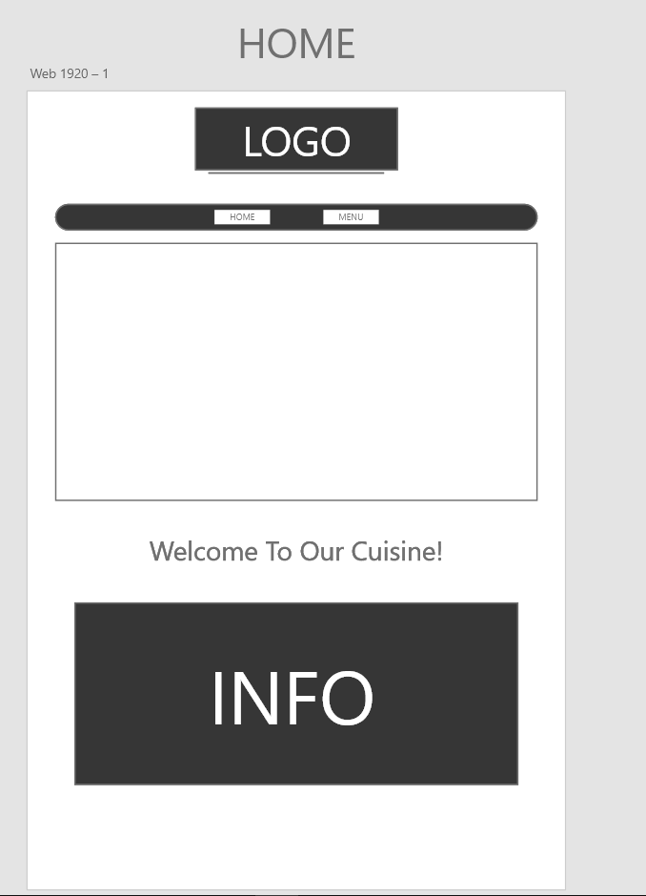

We choose the color #363636 (light black) as a main and #707070 (grey) as a second and border color. The logo was created using Photoshop and inspired by the same color #363636 and using a custom font (handwriting-draft free-version) (DaFont, u.d.):

We choose a page with centered elements so it’s easier for the eye to keep up. The navigation consists of “Home”, “Menu” and “Info”. The Menu is a dropdown button with “Lunch”, “Dinner” and “Snacks”. The website contains few and easy understanding concepts, like the menus with some space between, allergens explained at the bottom, and maps with a 2D and 360**°** view.

We created two models, the first that was done before submitting it to “AChecker” and “Markup Validation”. Where we had to change elements (achecker, u.d.) (validator.w3, u.d.):

* Create a class called dish-title in the Css and change the <strong> for the class.
* Fixed some <div> that were misplaced, they were not giving errors but you could see there was something wrong because of the warnings.
* Changed the <li> for <div> since they were giving errors in the buttons and added a class with the li characteristics.
* Removed the body section since it was giving error with the main div (Contect)

At the end we checked all elements of the site. Tested multiple styles, like having the navigation bar with no border (square), border all around, testing with different type of maps, type of container divs, logos and generally readability. The page were uploaded to GitHub and worked through it.

Sources

achecker. (u.d.). *AChecker Web Accessibility Checker*. Hentet fra achecker.achecks.ca: https://achecker.achecks.ca/checker/index.php

DaFont. (u.d.). *handwriting-draft.font*. Hentet fra dafont.com: https://www.dafont.com/handwriting-draft.font

validator.w3. (u.d.). *Markup Validation Service*. Hentet fra https://validator.w3.org/: https://validator.w3.org/#validate_by_upload